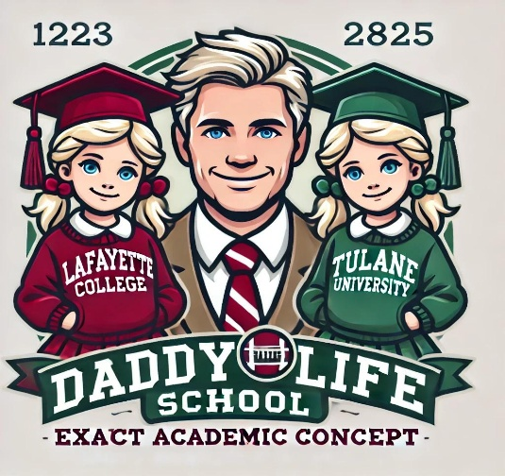

Allison Love Giebutowski

17 Columbine Road

Weston, MA 02493

Dear Allison,    
  
Congratulations! It is with great pride and an unbridled sense of optimism and fun that I’m sharing with you some fantastic news! You have been accepted to Daddy Life School! YAAAYYYYY!!!!

Your application reflected the drive, potential, and sense of responsibility that indicate your potential to thrive in the real world. We think you’re going to be a great adult! Our goal is to give you the skills to navigate the early stages of adulthood in a way that minimizes stress, keeps you on a responsible financial path, and ensures your safety.

Daddy Life School (DLS) is a world-class institution of learning and the undisputed leader in the field of developing high-potential teenagers into happy, productive, and responsible adults. We are a highly exclusive bastion of higher learning, as we are anticipating only accepting 2 students for 2025.

We have built our curriculum around the Daddy Life Pyramid. The three sides of the Pyramid are:

* + *Young Adulthood Budgeting*
  + *Early Career Planning and Success*
  + *Physical, Mental, and Sexual Health and Safety*

We feature highly experienced faculty, guest lectures, and our vaunted Study Abroad program. Well, not really “abroad” in the sense of flying out of the country, but we plan to travel beyond the confines of the 17 Columbine Campus. Either way, we plan to learn a lot but also have a blast along the way!

We invite you to attend an Orientation Session in the 1st week in February, with our first class scheduled for Sunday, February 9th at a time to be determined. In the meantime, please confirm your commitment to attend Daddy Life School by logging in to your Peter Pan Portal (PPP) and signing the DLS Code of Conduct. There’s no need to send in a non-refundable enrollment, because based on your stellar performance as a toddler and a teenager, you have been granted a full scholarship! Yes, Daddy Life School is FREE!  
  
As you are aware, under the Early Decision Plan, you have agreed upon admission to withdraw applications from all other Life Schools to which you have applied and matriculate to Daddy Life School.   
  
I am truly excited about you as a DLS Certified Adult! On behalf of the faculty, guest lecturers, and other student at Daddy Life School, I wish you the best for a happy and productive conclusion to your childhood experience, and I’ll look forward to seeing you at Orientation!  
  
With Great Love,

Big Baby Daddy  
  
**BIG BABY DADDY**

**Dean of Admissions, Daddy Life School**

**Department Chair, Financial Planning and Budgeting**

**Adjunct Professor, Life Health and Fitness**

**B.S. Business Administration, Boston College ‘85**

**MBA, Harvard Business School**